Software Design Document

<Info Calculator>

Ali ghaffari, Tadiwanashe Kunaka

Table of Contents

1.0 System Vision 3

1.1 Problem Background 3

1.2 System Overview 3

1.3 Potential Benefits 3

2.0 Requirements 4

2.1 User Requirements 4

2.2 Software Requirements 4

2.3 Use Cases 4

3.0 System Components and Software Design 5

3.1 System Components 5

3.2 Software Design 5

4.0 User Interface Design 6

# System Vision

## Problem Background

Manually looking at houses through the Airbnb Database is not ideal for a customer. Typically, customers who wish to rent a house do not want to learn data structure to rent. A lack of user interface is not ideal for a business as it does not make It easy to use the service. Most people who are computer literate lack coding knowledge, due to this having a user interface is important. This makes the service more appealing to use.

## System Overview

The ‘Info calculator’ will ask you for a suburb after you’ve entered a valid suburb, then the app will display houses that you can click on which display the prices for the rent and will also display the reviews.

## Potential Benefits

The benefits may include easier, quicker time and more pleasant time navigating through the house listings. With the ‘Info Calculator’ the user will have a filter system, rather than manually looking through the house listings. The filter will also display the prices with the reviews, so the user can make the decision of which house they prefer.

# Requirements

## User Requirements

The application “Info Calculator” is manly used for comparing Airbnb houses, in order to see what is more suitable for you. This is done by comparing things like, pricing, how much the property has been rated, and where the suburb is located. The Objective of the “Info Calculator” is to see what suits you the best, in order to speed up productivity and spend less time looking and comparing them yourself. The program is made for customers who are looking for a particular property. Customers who wish to use this application need to know basic app navigation skills with primary school level of English and mathematic.

## Software Requirements

The requirement for the user using this software is a laptop. Python is the language used in developing this program. Making this GUI program from python will require packages from the wx series.

## Use Cases & Use Case Diagrams

The Use of the Software “Info Calculator” is diverse and can be used for many situations. For a tourist wishing to travel abroad might want to plan their trip, they may want to book a property before arriving. Instead calling hotels and manually asking questions, the use of this software could be beneficial by using less time in order to get the answers they wanted without needing to call. Other instances of how this software could be useful is if Airbnb wanted to see what houses perform the best and why, they could use this information to better their services.

# Software Design and System Components

## Software Design

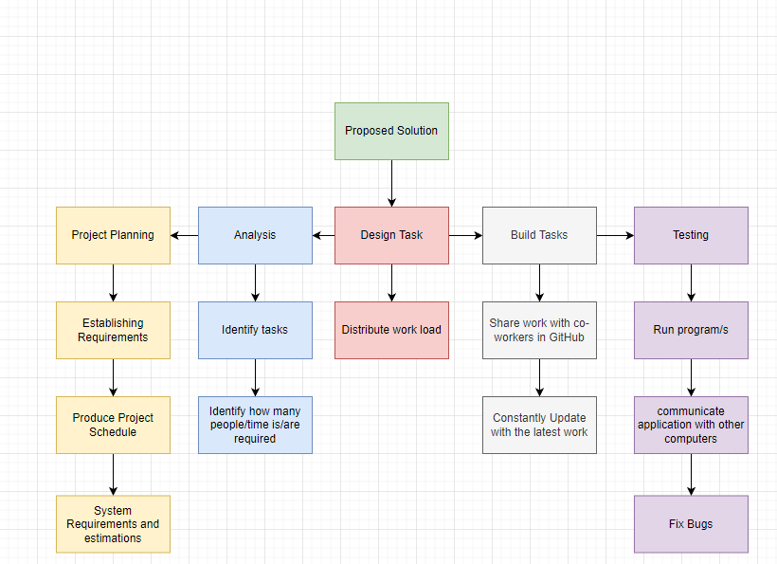

## System Components

### Functions

The program will ask for a suburb, which then will give you the price ranges and the reviews with the dates they were reviewed.

When entering a value such as a suburb the software will search the dataset and look for the cost of the property, the reviews will be displayed.

### Data Structures / Data Sources

A tree data structure is implemented in order to navigate through the application. while loops are used to loop through the reviews and houses, without while loops it would be difficult and would take a long time to use for loops.

### Detailed Design

Display ‘Search for suburb’

Display ‘Type a suburb’

Display ‘Go’

If search not found then

Display ‘ERROR! invalid input.’

If a suburb is entered then

Display houses with costs listed in the same suburb

If a house is clicked then

Display Reviews

# User Interface Design

The design process was done in Microsoft PowerPoint, this is done to get a preview of what the software will look like and how it will operate. By using Microsoft PowerPoint, I was able to design the app very quickly as it was very easy to use, and I was able to show how the app worked by showing the progress pictures of how they would work if you were to navigate through the app.

## Structural Design

When you search for an invalid suburb the program will show you a message, saying “ERROR Invalid input”. If the correct suburb is entered then it will display a range of houses, with their costs from the suburb. If you click the property, you want then, a page of reviews of that house will display.

## Visual Design

The design is simple, the primary colours are in Blue, but the background and edges of texts/boxes are black. This is so it is not too messy and easy to navigate through. Having a simple design is sometimes better than trying to design the app in a complicated way, this is to make it easier for customers.